Project Documentation: Multilingual Text-to-Speech Web Application

Project Overview
This project is a modern, fast, and multilingual Text-to-Speech (TTS) web application built entirely from scratch. It leverages a high-performance backend, a responsive frontend, and integrates state-of-the-art zero-shot voice cloning technology to generate highly realistic speech in multiple languages based on a single 3-second audio sample.

1. Frameworks & Libraries Used
The application is built on a modern, decoupled tech stack:

Backend & Web Server:
- FastAPI: Chosen for its high performance, asynchronous capabilities, and automatic API documentation generation. It handles routing and frontend-to-backend communication.
- Uvicorn: An ASGI web server implementation used to run the FastAPI application efficiently.

Artificial Intelligence & Machine Learning:
- Coqui TTS (XTTS-v2 Model): The core AI engine. XTTS-v2 is a state-of-the-art deep learning model capable of zero-shot voice cloning and multilingual speech generation.
- PyTorch (with CUDA 11.8): The underlying mathematical framework powering the AI. The CUDA-enabled version was specifically installed to offload massive neural network calculations to the NVIDIA GPU, reducing generation time from minutes to mere seconds.
- Transformers (Hugging Face): Used internally by Coqui to manage model architectures. (Version locked to 4.38.2 to ensure stability with PyTorch 2.1.2).

Frontend:
- HTML5 / CSS3: Structured with a clean, modern, and responsive user interface.
- Vanilla JavaScript: Handles asynchronous API fetch requests, dynamic DOM manipulation (populating supported languages), and UI state management (loading spinners).

Utility Libraries:
- aiofiles: Enables asynchronous saving of generated .wav files to prevent server blocking.
- python-multipart: Implemented to future-proof the architecture, allowing for eventual direct user uploads of voice reference files.

2. Project Folder Structure
The project follows a modular, professional directory structure separating the application logic from static assets.

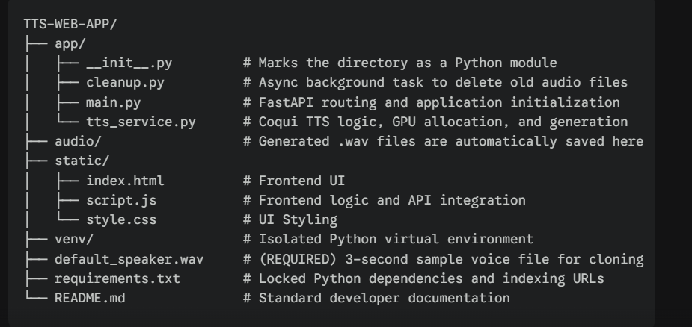

3. Prerequisites & Setup
To deploy or test this application on a new machine, the following setup is required.

Prerequisites:
1. Python 3.9, 3.10, or 3.11 installed.
2. A single, clear 3 to 5-second audio file of a native speaker, placed in the root directory and named default_speaker.wav.

Installation Steps:
- 1. Initialize Virtual Environment:
Open the terminal in the root directory and isolate the environment:
python -m venv venv
venv\Scripts\activate
- 2. Install Dependencies:
All dependencies, including the specific CUDA-enabled GPU versions of PyTorch, are locked in the requirements file.
pip install -r requirements.txt
- 3. First-Time Model Initialization:
Upon the first execution, the backend will automatically connect to Hugging Face and download the ~1.87 GB XTTS-v2 model weights to the local machine's cache.

4. How to Run the Application
Because the application logic is encapsulated within the app module, the server must be started from the root directory (TTS-WEB-APP).
- 1. Start the Server:
Execute the following command in the terminal:
uvicorn app.main:app --reload
- 2. Access the Interfaces:
- Web User Interface: Open a web browser and navigate to http://localhost:8000
- Swagger API Documentation: Navigate to http://localhost:8000/docs to view and test the backend endpoints directly.

5. Application Workflow & Features
- Dynamic Language Loading: On load, the frontend queries the backend to determine exactly which languages the loaded AI model supports, automatically populating the UI dropdown.
- Zero-Shot Voice Cloning: When a user clicks "Generate," the AI analyzes the acoustic properties of default_speaker.wav and uses those characteristics to synthesize the inputted text in the selected language.
- Non-Blocking Architecture: Audio generation is computationally heavy. The backend offloads this to an asynchronous background thread (asyncio.to_thread), allowing the server to remain responsive to other web requests.
- Automated Storage Management: A background worker (cleanup.py) runs every 5 minutes, automatically scanning the /audio directory and deleting any generated .wav files older than 10 minutes to prevent storage bloat.

